All notepad files:
All Notepad files

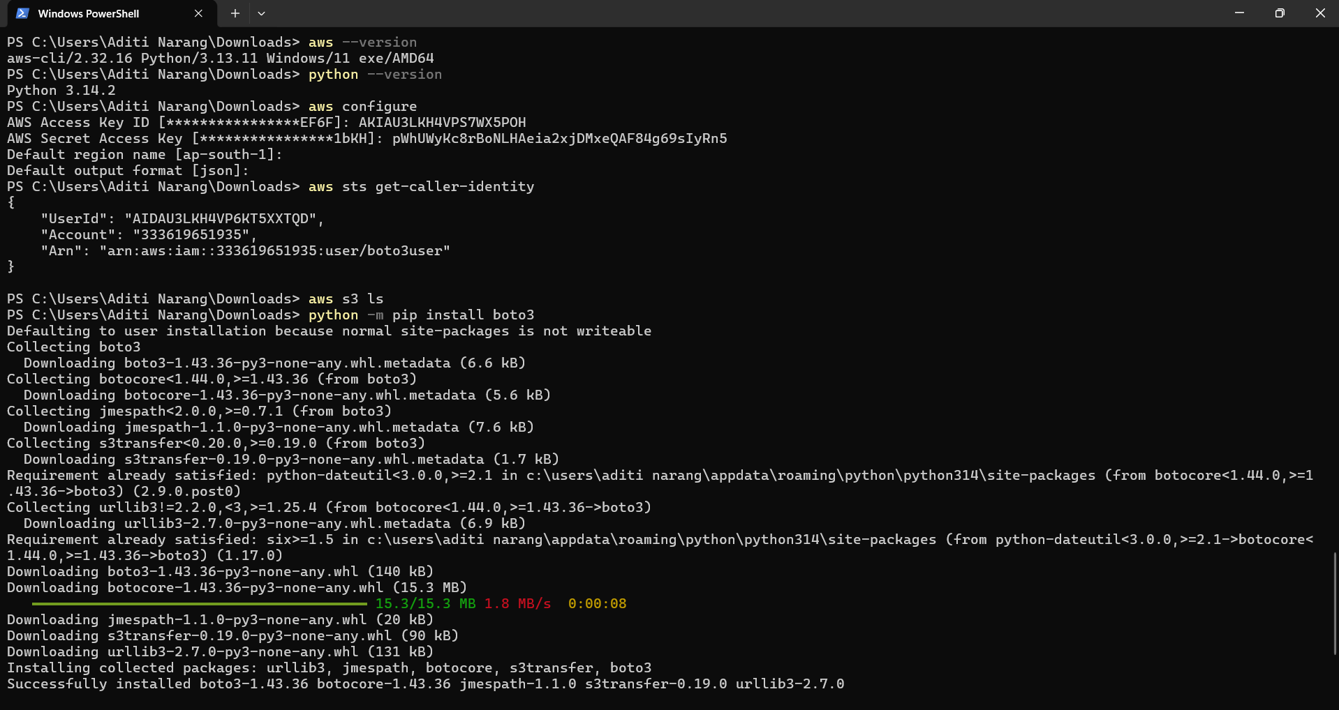

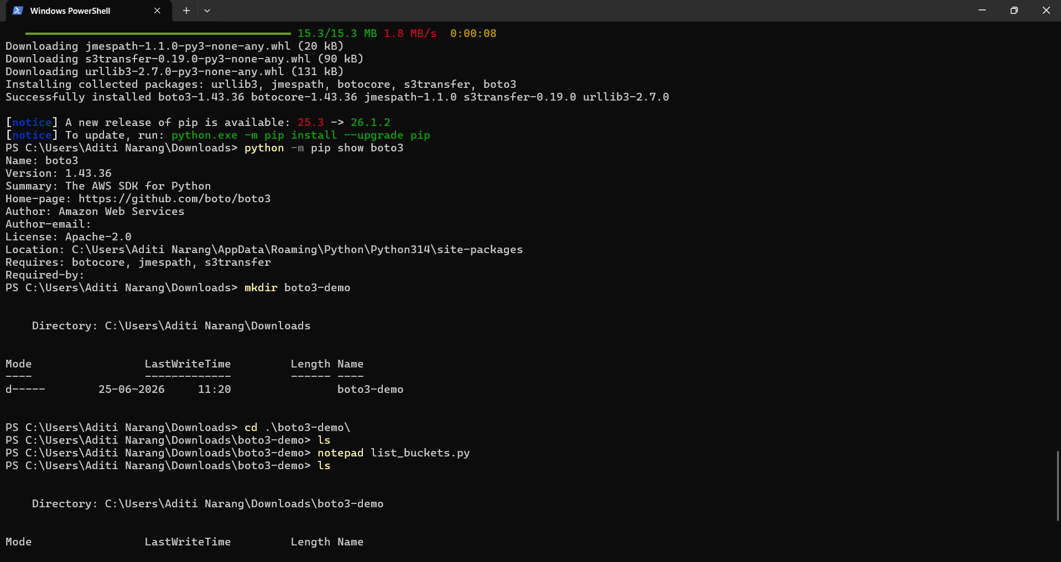

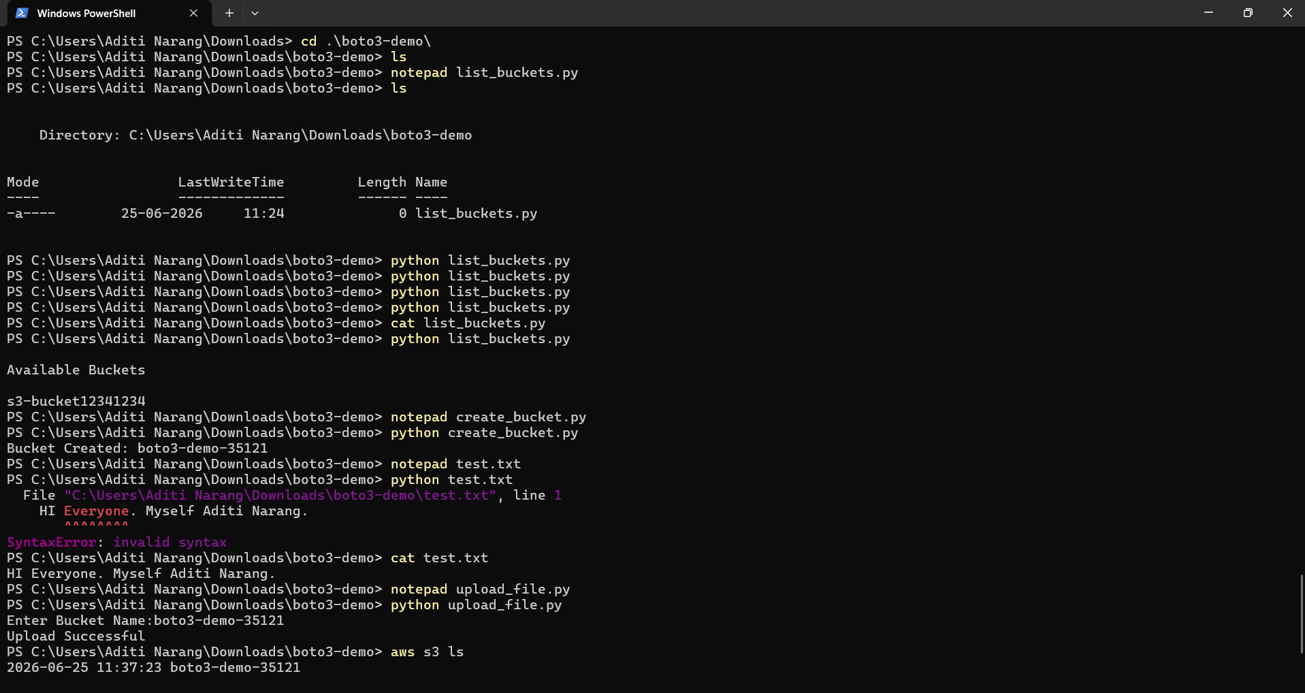

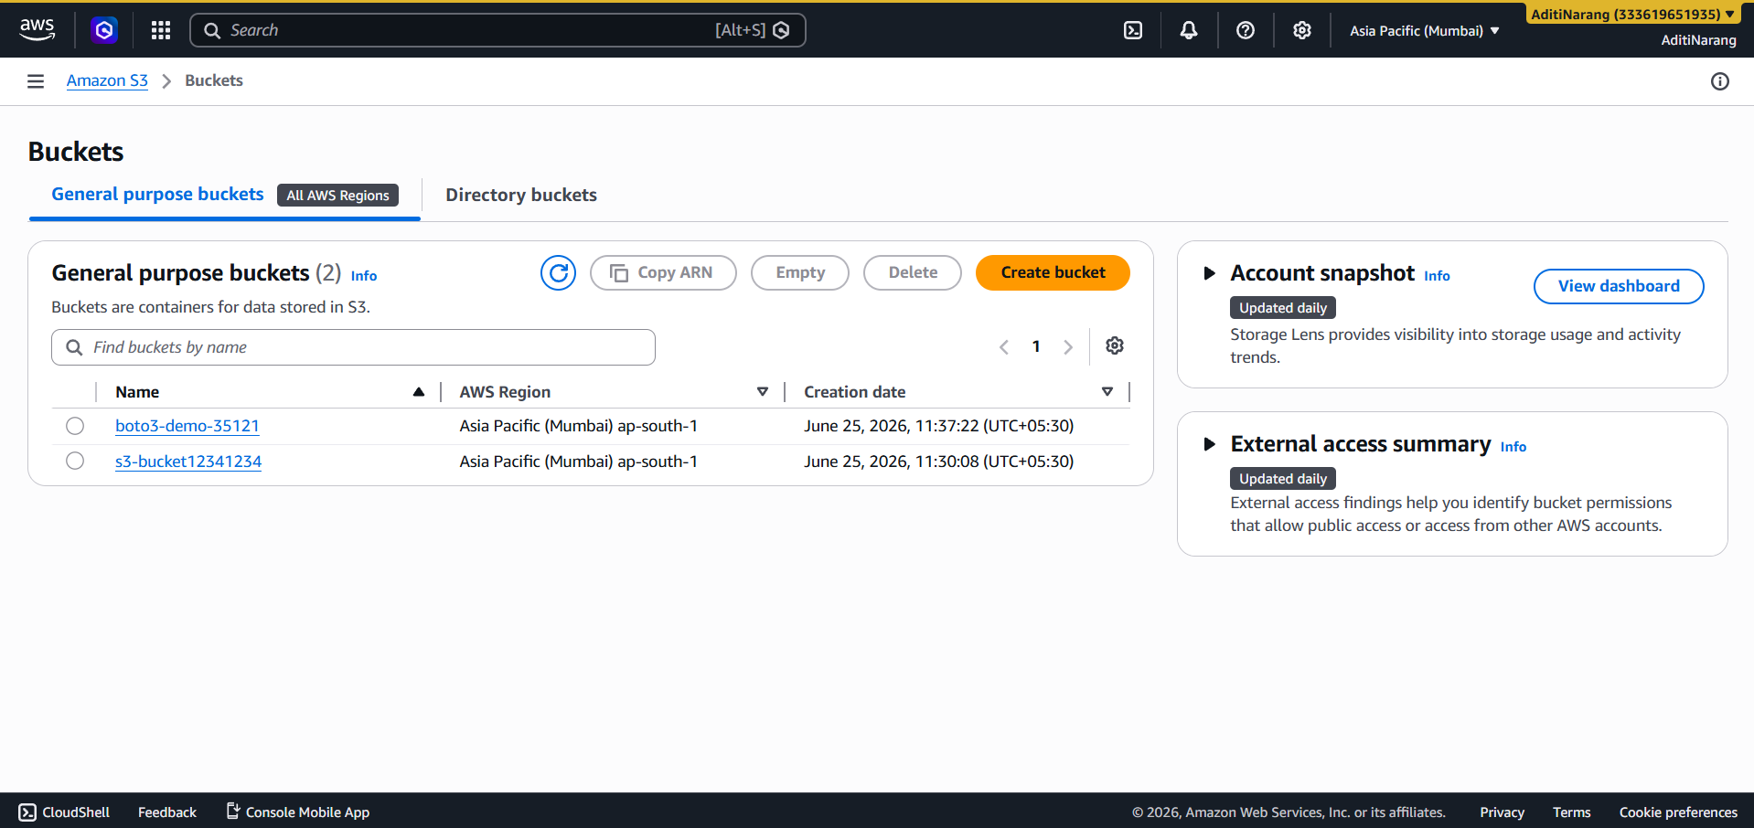

s3-bucket12341234phle se exist kar rahi thi.

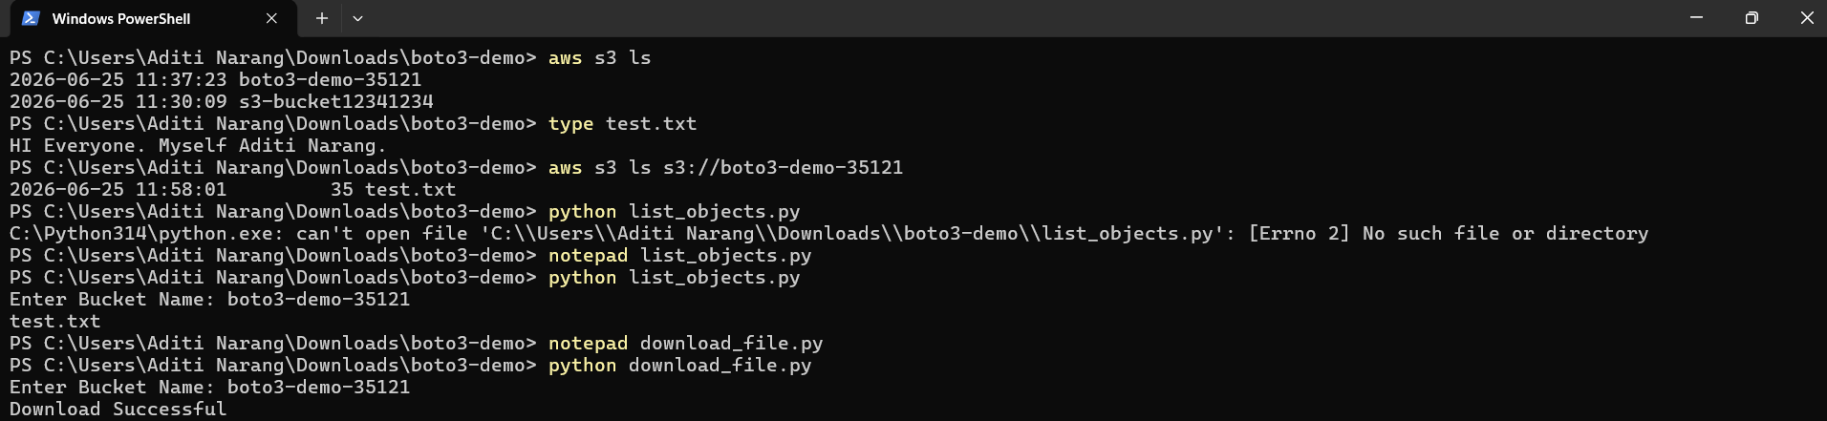

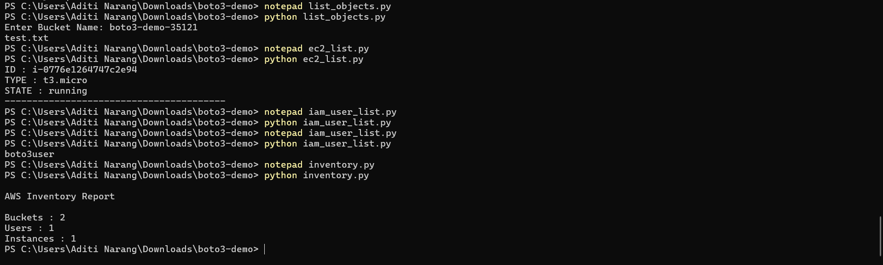

Iske baad ka cli ka ek screenshot missing hai, jisse instances bane the, but no worries unki script hai, so we have to do:
notepad create_ec2_instance.py ( then paste the text)
python create_ec2_instance.py

notepad create_ec2_second_instance.py ( then paste the text)
python create_ec2_second_instance.py

